## Project Design Phase Problem – Solution Fit Template

|  |  |
| --- | --- |
| Date | 26 June 2025 |
| Team ID | LTVIP2025TMID53123 |
| Project Name | ResolveNow: Your Platform for Online  Complaints |
| Maximum Marks | 2 Marks |

**Problem–Solution Fit Template – ResolveNow** **Problem Identified**

Many users face delays, poor communication, and lack of transparency when registering and resolving complaints through traditional channels. There’s no real-time status tracking, no agent interaction, and often no confirmation or follow-up, leaving users frustrated and helpless.

## Proposed Solution

**ResolveNow** is a full-stack online platform that allows users to:

* Register complaints easily
* Track complaint status in real-time
* Chat directly with assigned agents
* Receive notifications and resolution updates
* Submit feedback post-resolution

## Purpose Alignment

**Solve complex problems in a customer-focused way**

We address the pain of poor complaint handling by streamlining the entire process into a digital, responsive system.

## Faster solution adoption

We built ResolveNow using technologies that users already interact with daily (web apps, email, chat) for easy onboarding.

## Effective communication and marketing

By offering transparency, notifications, and agent communication, we create trust and engagement.

## Increased user touchpoints

Users interact via dashboards, emails, chat, and feedback forms—enhancing the customer experience and platform credibility.

## Improve existing complaint processes

Our platform replaces outdated systems by offering accountability, visibility, and faster resolution.

**Template:**

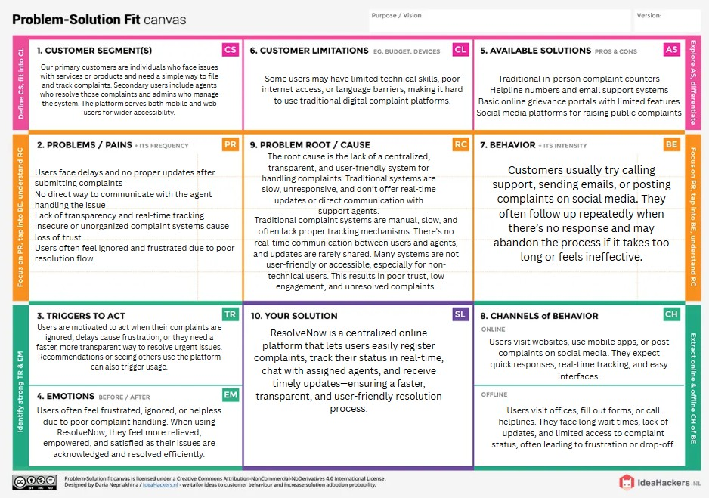

# WHO IS YOUR CUSTOMER?

Our customers are individuals, citizens, or consumers facing issues with services or products and seeking a faster, transparent, and responsive way to register and resolve complaints— through web or mobile.

# EXPLORE LIMITATIONS TO BUY/USE YOUR PRODUCT OR SERVICE

Some users may lack digital literacy, have limited internet access, or prefer local language support. Trust issues with digital systems may also limit usage.

# HOW ARE YOU GOING TO BE DIFFERENT THAN COMPETITION?

Unlike traditional or basic complaint portals, **ResolveNow** offers real-time status tracking, direct agent chat, smart notifications, and a smooth, user-friendly interface with both mobile and web access.

# FOCUS ON FREQUENT, COSTLY, OR URGENT PROBLEM TO SOLVE

We focus on solving delays and lack of transparency in complaint resolution—a problem that affects large user groups regularly and leads to user dissatisfaction and service loss.

# UNDERSTAND THE CAUSE OF THE PROBLEM

The core issue is that existing systems are outdated, lack real-time features, offer no agent communication, and are not centralized or user-focused.

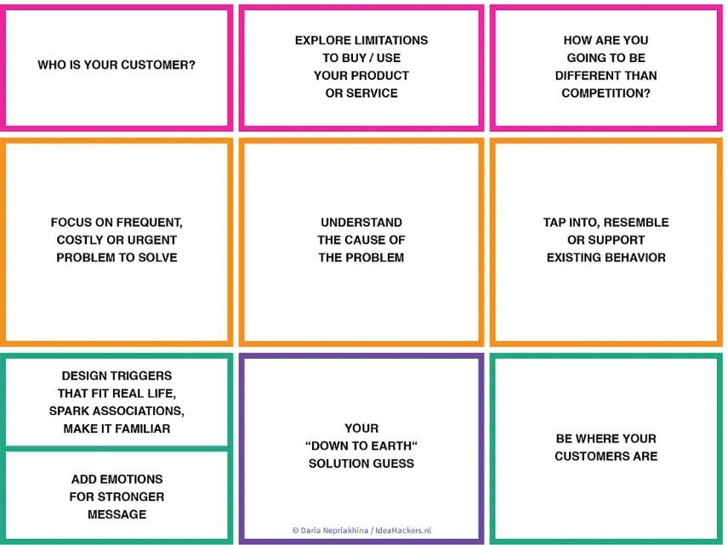

# TAP INTO, RESEMBLE, OR SUPPORT EXISTING BEHAVIOR

We designed ResolveNow to align with how users already behave—using apps for communication, expecting live updates, and preferring instant responses like those seen in chat or food delivery apps.

# DESIGN TRIGGERS THAT FIT REAL LIFE, SPARK ASSOCIATIONS, MAKE IT FAMILIAR

Triggers like complaint confirmation emails, real-time status change alerts, and instant chat replies are designed to mimic familiar experiences from apps like WhatsApp or Swiggy— making the process intuitive and trustworthy.

# ADD EMOTIONS FOR STRONGER MESSAGE

We aim to reduce frustration and build trust. Users feel heard, informed, and respected when their complaints are acknowledged and resolved transparently.

# YOUR "DOWN TO EARTH" SOLUTION GUESS

A clean, easy-to-use platform that lets users submit complaints, track status, talk to agents, and receive timely updates—all from their phone or computer—without complex processes or long waiting times.

# BE WHERE YOUR CUSTOMERS ARE

ResolveNow is accessible via mobile and desktop, integrates email and (optionally) SMS updates, and can be promoted through social media and service portals—meeting users where they already are.

## References

* 1. IdeaHackers – Problem-Solution Fit Canvas

 <https://www.ideahackers.network/problem-solution-fit-canvas/>

* 1. Medium by Epicantus – Problem-Solution Fit Canvas [https://medium.com/@epicantus/problem-solution-fit-canvas-aa3dd59cb4fe](https://medium.com/%40epicantus/problem-solution-fit-canvas-aa3dd59cb4fe)